

Voice Assistance
  - ai - ASSISTANCE to help user
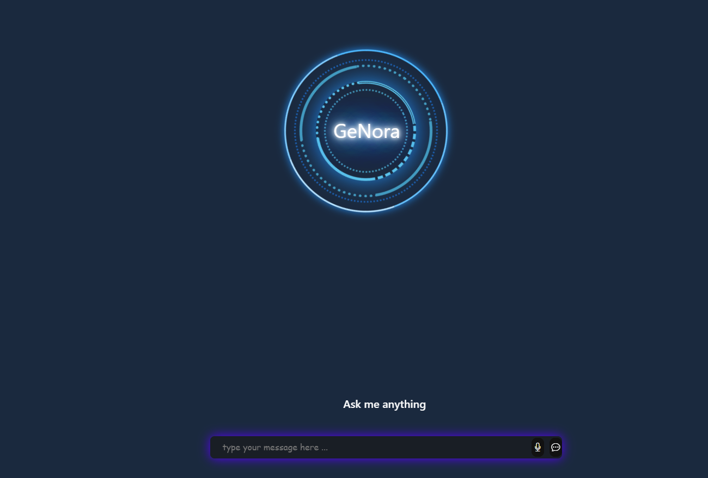

Computer Science | CS 499B | first Semester 2025/2026
FINAL YEAR GRADUATION PROJECT
Template



Computer Sciences Department
Faculty of Information Technology and Computer Science
Yarmouk University
Irbid, Jordan

Graduation Project Report

BSc Project
CS Department
Project ID: YUIT-CS–XX-XXX

Ai-Voice Assistance
Assistance to help user open sites and apps

Moataz Mdallal – 2020901188
Roa’a meqdadi - 2020901053

Department of Computer Science
Faculty of Information Technology and Computer Sciences
Yarmouk University, Jordan

Author(s):
Moataz Mdallal , 2020901188
E-mail: moaatazmodallal2@gmail.com
Roa’a meqdadi – 2020901053

University supervisor(s):
Firstname Lastname
Department name
Co-supervisor (if applicable):
Firstname Lastname
Company/Organization full name
Address:
Phone: International standard, e.g. use +
Department of Computer Science Internet: http://yu.edu.jo
Faculty of Information Technology Phone: +962 2 72711111 Ext. 6710
and Computer Science
Yarmouk University Jordan Fax : +962 2 7211111

Intellectual Property Right Declaration

This is to declare that the work under the supervision of _____________________ having title “ Ai-Voice Assistance ” carried out in partial fulfillment of the requirements of Bachelor of Information Technology in Computer Science, is the sole property of the Yarmouk University and the respective supervisor and is protected under the intellectual property right laws and conventions. It can only be considered/ used for purposes like extension for further enhancement, product development, adoption for commercial/organizational usage, etc., with the permission of the University and respective supervisor.

This above statement applies to all students and faculty members.
Date: ______________
Author(s):

Name: Moataz Mdallal | Signature: _____________________
Name: Roa’a meqdadi | Signature: _____________________

Supervisor(s):

Name: Firstname Lastname Signature: _____________________

Anti-Plagiarism Declaration
This is to declare that the above publication produced under the supervision of________________________________________________________having title “ Ai-Voice Assistance ” is the sole contribution of the author(s) and no part hereof has been reproduced illegally (cut and paste) which can be considered as Plagiarism. All referenced parts have been used to argue the idea and have been cited properly. I/We will be responsible and liable for any consequence if violation of this declaration is proven.

Date: ______________
Author(s):

Name: Firstname Lastname Signature: _____________________
Name: Firstname Lastname Signature: _____________________
Name: Firstname Lastname Signature: _____________________

ACKNOWLEDGMENTS

This work is dedicated to my dear parents, family and friends , we are all thankful for support , we also want to thank Computer Science Department and Dr.Ra’fat for help and support

ABSTRACT
This project build for help users to start APPs and URLs , used eel library to connect backend with python programming language , playsound to make python codes play local sounds when click on mic button, pyttsx3 ( text-to-speech ) make written text to speak , SpeechRecognition launched by google nest use mic as input

Features included : launch apps , web search , play youtube videos , weather information , test speed internet , control volume , take screenshot ,

Keywords : assistance, helper . run apps and search google , system control

Chapter 1 INTRODUCTION
1.1 Purpose of the Project
1.2 Purpose of this Document
1.3 Overview of this Document
1.4 Existing System
1.4.1 Existing system description
1.4.2 Problems in the existing system

Chapter 2 SYSTEM ANALYSIS
2.1 Data Analysis
2.1.1 Data flow diagrams
2.1.2 System requirements
2.1.2.1 Functional and data requirements
2.1.2.2 Non-functional requirements
2.1.2.2.1 Look and feel requirements.
2.1.2.2.2 Usability requirements
2.1.2.2.3 Security requirements
2.1.2.2.4 Performance requirement
2.1.2.2.5 Portability requirements
2.1.3 Class Diagrams
2.1.4 Proposed Solutions
2.1.5 Alternative Solutions

Chapter 3 DESIGN CONSIDERATIONS
3.1 Design Constraints
3.1.1 Hardware and software environment
3.1.2 End user characteristics
3.2 Architectural Strategies
3.2.1 Algorithm to be used
3.2.2 Reuse of existing software components
3.2.3 Project management strategies
3.2.4 Development method
3.2.5 Future enhancements/plans

Chapter 4 SYSTEM DESIGN
4.1 System Architecture and Program Flow
4.1.1 Major modules
4.1.2 Sub modules
4.2 Detailed System Design
4.2.1 Detailed component description

Chapter 5 IMPLEMENTATION AND VALIDATION

Appendix A CODE

CHAPTER 1

- Introduction

Voice assistance is software agent can interpret human speech and respond via voice and can interact through speakers

  - purpose of the project
the primary purpose of this voice assistance project to help people to open apps , website and search google by voice or writing in text input with specific words by create interactive and intelligent desktop assistant , we aim to strengthen core programming skills between python-javascripts , speech processing and database management , we use database to make program know what is the file or website should open or start , its User-Friendly design

  - Purpose of document
This document represents a comprehensive report explains process for each stage of development, and show the result we were able to achieved

  - Overview of this document
This document cover the system purpose and software components, how designed , development process and other details

  - Existing Systems
    - Existing systems and their description
- Google assistant : a virtual personal assistant
Its developed by google LLC ( 2021 ) , uses deep learning for natural language and speech recognition , serve google services for tasks like web search and control smart home

- Amazon alexa : voice service
Developed by amazon INC ( 2020 ) , voice-controlled assistant that use automatic speech recognition to process commands , alexa aim for activate hands-free world and support thousands of third party tools , its integrated with IoT devices to create specific task

    - Problem in existing systems
Google assistant : privacy like send all voice data to google servers for processing , not working offline need continuously internet connection

Amazon alexa : requires from developers to follow strict amazon guidelines

Conclusion
While existing voice assistant powerful voice recognition but they focus on cloud based processing rather than local control and privacy , my project fix this gap using desktop program and local speech recognition processing , and prove voice assistant can work without continuously internet connection to connect cloud based

CHAPTER 1
  - Data Analysis
    - Data Flow Diagram
Context diagram
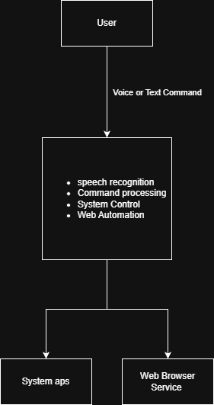

Level 1 data flow diagram
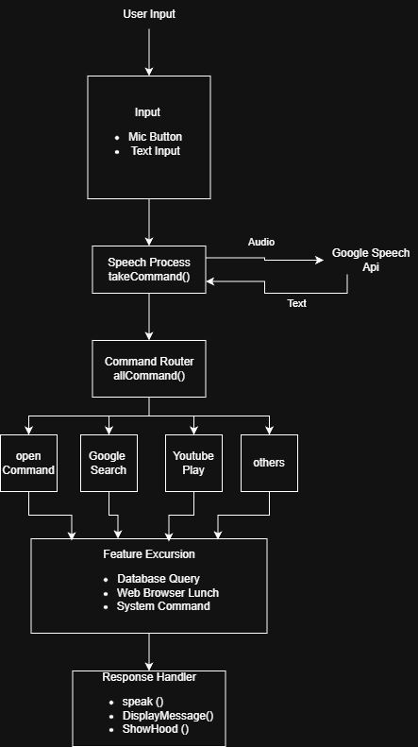
    - System Requirements
      - Clients, Customers, and Users (Use-Case Diagram)

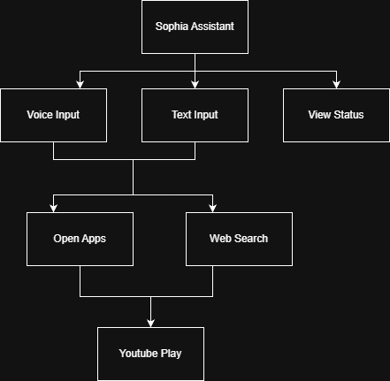

Actors
- End user : who using voice or text to contact the assistant
- System : Windows ( Operating System)
- Web Services : Google , Youtube

2.1.2.2 Functional and Data Requirements
2.1.2.2.1 Functional Requirements
1. Speech Recognition
        - Must capture audio from user mic
        - Convert speech to text ( using google speech recognition)
        - Handle recognition timeouts(10sec) , phrase limits ( 6 sec)

2. Text To Speech ( TTS )
        - Use pyttsx3 to convert text to speech
        - System use female voice with rate 200WPM
        - Sync speech with display messages

3. Command Processing
        - Parse voice or text input for keywords
        - Route command to feature handler
        - Support ( open , search , google , youtube ) commands

4. Application Control
        - Open system applications using query
        - Open websites using URL
        - Use os.system() for unlisted apps

5. web integration
        - Perform Google search with URL encoding
        - Play youtube videos using pywhatkit LIB
        - Open browser for search results

6. weather information
- Use open-meteo API to know current weather
- Display as ( C )
- Use city weather queries

7. test speed internet
- Use Mbps to show download speed
- Show latency in milliseconds
- Use google as server for reliable

8. monitor system
- Percent usage of ( cpu and ram )
- For system metrics use psutill library
- Monitor real-time performance

9. control volume
- Increase and decrease volume
- Mute / unmute volume

10. take screenshot
- Capture full screen
- Save with timestamp

11. time and date service
- Use 12-hour format to speak current time
- Use ( day , month dd , yyyy ) format to speak current date
- Use library datetime for accuracy

12. Database Management
        - Maintain SQLite with two tables
        - sys_commands for application paths
        - web_commands for website URLs

13. User Interface
        - display animated loader
        - show siriwave during assistant speaking
        - update message status real time

14. Audio Feedback
        - play click sound when microphone is activated

2.1.2.2.2 Data Requirements
1. Voice Input Data
        - Description: capture from mic
        - Processing: Google Speech Recognition API
        - Output : Text string ( in lowercase )

2. command String
        - Description: user command with parsing
        - Format : string ( lower case )
3. Databasae records
        - sys_commads table
- name : app name ( string )
- path : full path of app ( string )
        - web_commands table
- name : name of website ( string )
- url : full url ( string )

4. test speed internet
- Download speed : mbps ( float )
- Latency : milliseconds ( integer )
- Server : google ( no content )

5. system information
- cpu : percentage usage ( float )
- memory : percentage usage ( float )
- library : psutil

6. screenshot data
- ffilename : screenshot_YYYYMMDD_HHMMSS.png
- location : ./screenshots/folders
- format : png

7. time and date
- time format : hh:mm am/pm
- date format : day , month DD,YYYY

8. speech output
- description : voice response
- engine : pyttsx3
- rate 200 wpm ( word per minute )

9. youtube search
- description: extract search query
- pattern : between ( paly ) and ( on youtube )
10. Google search
- description: extract search query
- pattern: have ( search , google , on google ) in text
to make it easy to understand
Type | Keyword | Called function | Example
open app/website | open | openCommand() | “open notepad”, “open x “
youtube | on youtube | PlayYoutube() | "play music on youtube"
google search | on google, google, search | SearchGoogle() | "search python", "google tutorials"
speed test | 'speed test', 'internet speed' | CheckInternetSpeed() | "check internet speed", "speed test"
date | date | TellDate | “ what is the date “ , “ tell me the date “
time | Time | TellTime() | "what time is it", "tell me the time"
system info | system info , cpu , memory | SystemInfo() | "system information" , "check cpu"
volume up | Volume Up | VolumeUp() | "increase volume", "volume up"
volume down | volume down | VolumeDown() | "decrease volume", "volume down"
mute | mute | VolumeMute() | "mute volume", "mute"
screenshot | screenshot | TakeScreenshot() | "take screenshot", "capture screen"

2.1.2.3 non- functional requirements
2.1.2.3.1 look requirements
- animated design with circle loader
- use blue gradient for visual
- smooth animation using ccs keyframe and textillate.js
- include neon glow on ( SOPHIA )
2.1.2.3.2 Usability Requirements
- able to give commands via mic with a click
- type command
- provide clear status message

2.1.2.3.3 security requirements
- local processing : recognition use google api but stored local
- database security : contains just paths and URLs there is not any personal data
- audio privacy : activate mic just after click mic button
2.1.2.3.4 Performance Requirements
- recognition latency
- complete in 10 sec
- phrase limit 6 sec
- response time
- launch execute in < 2 sec
- open browser in < 3 sec
- queries complete in < 100 ms
- ui response
- animation maintain 60 fps
- update message instantly
- resource usage
- cpu usage not exceed 15% during idle state

2.1.2.3.5 portability requirements
- operating system: widows ( os.startfile() , windows paths )
- browser : browser based on chromium for eel
- py version : 3.12.0 to work at best case
- dependencies: available by pip
- database : SQLite is cross platform database

2.1.3 class diagram
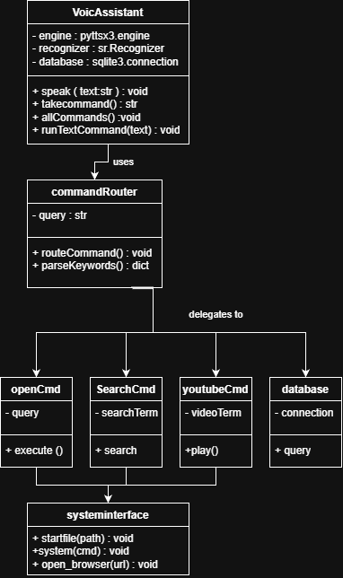
2.1.4 proposed solution
Our project delivers privacy focus and designed to improve productivity by commands . use customizable features to combine speech processing

Key features :
Two input methods: mic ( speak ) and keyboard type
Driven command : SQLite storage for shortcuts
Visual feedback : animated message with siriwave visualization
Web integration: direct search on google and playback youtube
Offline : work without internet

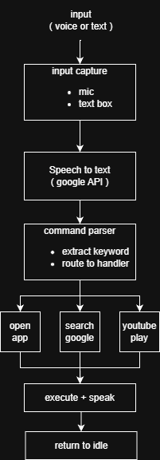
System Workflow:

2.1.5 alternative solution
1. CMU sphinx ( offline speech recognition)
- Pros : full offline , no API
- Cons : low accuracy , doesn’t have noise suppression
- Why not chose : google api give better accuracy
2. natural lang process ( NLP )
- Pros : context awareness, more command understanding
- Cons : require training, higher complexity
- Why not chose : need time for train and keyword matching
3. cloud based assistant ( AWS alexa )
- Pros : pro grade recognition
- Cons : required continuously internet connection , low privacy
- Why not chose : focus on local control

CHAPTER 3

3.1 design constraint
3.1.1 hardware and software environment
Hardware requirements
- Processor: Intel Core i3 equivalent (2.0 GHz minimum)
- RAM: 4GB minimum (8GB recommended for smooth operation)
- Storage: 200MB free space (for application and audio files)
- Microphone: Any standard USB or built-in microphone
- Speakers/Headphones: Required for audio feedback
- Internet: Required for speech recognition API calls
Software requirements
1. backend
- Python 3.7 or higher
- pyttsx3 (Text-to-Speech engine)
- speech_recognition (Google Speech API wrapper)
- pywhatkit (YouTube automation)
- playsound (Audio playback)
- eel (Python-JavaScript bridge)
- sqlite3 (built-in database)
2. frontend
- HTML5/CSS3/JavaScript (ES6+)
- jQuery 3.6.4
- Textillate.js (text animations)
- SiriWave.js (audio visualization)
- Bootstrap 5.0.2
- Bootstrap Icons
3. browser
- Google chrome ( for eel )
4. operating system
- Primary : Windows ( 64-bit )
- Secondary: mac or linux(required modification for paths)
5. APIs
- Google speech recognition API
3.1.2 end user characteristics
Sophia designed for quick access to application and web services using voice or text command
Targeted users
- Skill level : basic computer awareness
- Age : 15+ ( with reading ability)
- Use cases :
  - Quick application launch
  - Search web handfree
  - Play video
- User expectation
  - Instant response
  - clear feedback
  - Reliable speech recognition
3.2 Architectural Strategies
3.2.1 used algorithm
1. Speech recognition pipeline
- Audio -> noise filter -> feature extraction -> Google API -> text output
- Noise adjustment: adjust_for_ambient_noise() to adjust background sound level

2. Command Parsing Algorithm:

PYTHON CODE
def parse_command(query):
query = query.lower().strip()
if 'open' in query:
return ('OPEN', extract_app_name(query))
elif 'on youtube' in query:
return ('YOUTUBE', extract_yt_term(query))
elif 'on google' or 'search' or 'google':
return ('GOOGLE', extract_search_term(query))
else:
return ('UNKNOWN', query)
3. internet speed
- Latency:
  - Timer start -> request google server -> get response -> timer stop -> calculate time -> return in millisecond
- Download :
  - Timer start -> stream file with size 1 MB -> bytes count -> stop at 1 MB -> calculate ( bytes *8 )/( time * 1,000,000 ) -> return Mbps
4. screenshot algorithm
- Create timestamp -> screen capture -> save png -> speak confirm
3.2.2 reuse of existing software components
Component | Purpose | License
Eel | py-js bridge | MIT
Pyttsx3 | Offline text to speech | MPL 2.0
SpeechRecognition | Google Speech API | BSD
pywhatkit | YouTube automation | MIT
jQuery | DOM manipulation | MIT
Textillate.js | Text animations | MIT
SiriWave | Audio visualization | MIT
Bootstrap | UI framework | MIT
SQLite | Database engine | Public Domain

Custom Components:
- command.py: Command routing
- features.py: Feature implementations
- controller.js: UI management
- main.js: Event handling

3.2.3 project management strategies
- Define clear goals : establish (voice recognition, command execution) before implementation
- Modular development: separate ( speech , commands ) into independent modules
- Version control : track changes using git
- Testing: separate test for each
3.2.4
We chose agile as methodology
- Individual over processing
- Working software with full documentation
- Responding to change with a plan

3.2.5 future enhancement
- upgrade command set
  - Weather information
  - Email reading
- Customize features
  - Theme selection
- Ai chatbot
  - Chat gpt for questions
- Mutli language
  - Add auto detection language like Arabic
- Mobile application
  - Android / ios app

CHAPTER 4
4 system design
4.1 system architecture

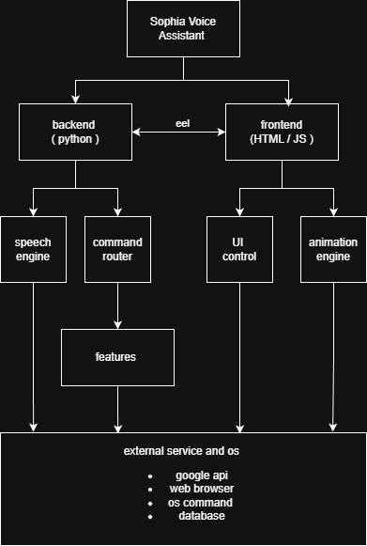
4.1.1 major modules

Module Descriptions
- Main application ( main.py )
  - Starting file which initialize eel server
  - Open browser window localhost:8000
  - Load www directory for frontend
- Speech engine ( command.py )
  - Speech to text
  - Text to speech
  - Route command
- Features ( features.py)
  - Launch apps
  - Search web
  - Paly youtube videos
- UI control (controller.js )
  - Display messages
  - Show current status
- Event handler ( main.js)
  - Click button
  - Animate visualization
4.1.2 sub modules
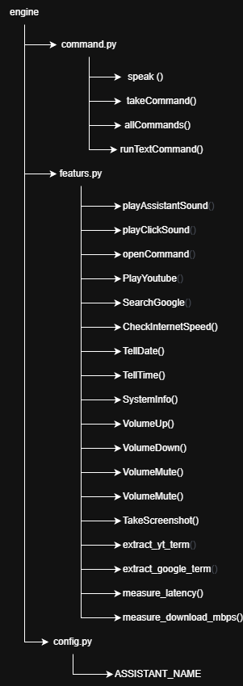
Backend module

Frontend Modules
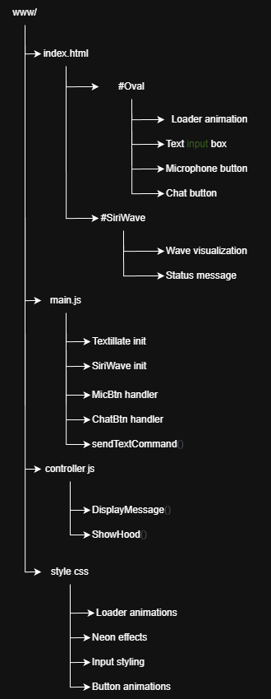

Database Module
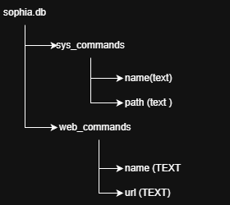

4.2 detailed system design
4.2.1 Detailed Component Description
- Speech Recognition Component (command.py)
  - Take command ( python function )
Purpose : recognize speech input
Flow:
    - Set mic as source
    - Adjust noise ambient
    - Show listening…
    - Listen for audio
    - Show recognizing …
    - Use audio in google api
    - Return lowercase text after recognize
  - Speak()
Purpose : text to speech
Flow
- Start pyttsx3 engine
- Get voice
- make speech rate to 200 WPM
- DisplayMessage() for UI update

- Command Routing Component (command.py)
  - allCommands ( python function )
purpose : process voice command
flow :
- use takeCommand() to take command
- check for keyword -> if open use openCommand , if on google or google or search use SearchGoogle , if on youtube use PlayYoutube , if not anyone print not run
- call showhood() return to idle
- runTextCommand() ( python function )
flow :
- (like allCommands() with text parameter)
- Lowercase text
- Apply routing commands
- Feature Execution Component (features.py)
- openCommand() ( python function )
purpose lunch sites or apps
algorithm:
- remove assistant name and open keyword and trime
- if found in sys_commands -> launch via os.startfile() , if found in web_commands open URL , if not found in in sys_commands or web_commands try os.system(‘start’ ) , on exception speak error
  - SearchGoogle() ( python function )
Purpose: Google web search
Flow:
- Extract search term
- If term found Speak "searching [term] on google" , if not found speak error
  - PlayYoutube() ( python function )
Purpose: Play YouTube video
Flow:
- use extract_yt_term()
- if found speak playing term on youtube by calling kit.playonyt(term) , if not found speak error
- UI Control Component (controller.js)
  - DisplayMessage() ( js function )
Purpose update message with animation
Flow:
- Receive message from Python
- Update siri-message
- Restart animation
  - ShowHood() ( js function )
Purpose: Return to idle view
Flow:
- Show #oval and hide #SiriWave
- Event Handling Component (main.js)
  - Microphone Button Handler ( js )
Purpose: Activate voice input
Flow :
    - clicks #MicBtn
    - Hide #Oval and Show #SiriWave
    - Use eel.playClickSound() and eel.allCommands()()
- Text Input Handler ( js )
Purpose: handle typed commands
Flow :
  - types in #chatbox
  - clicks #ChatBtn OR presses Enter
  - Trim text
  - Call eel.runTextCommand(text)()
  - Clear input box
- Animation Component (style.css + main.js)
  - Loader Animation (css)
Four rotating rings
- Outer ring: solid border
- Second ring: dotted border
- Third ring: mixed border
- Inner ring: dotted border
Colors : Blew gradient
Rotation: 360 degree
- Textillate Animation ( js )
Configuration :
- Loop : continuous
- In effect : bounceIn and fadeInUp
- Out effect: bounceOut and fadeOutUp
- SiriWave Visualization ( js )
Configuration:
- Style: iOS 9
- Speed: 0.1

CHAPTER 5
5.1 Implementation
Sophia developed like a full stack desktop app using python as backend and ( HTML , JS , CSS ) frontend with Google API for speech recognition
Development lifetime
- Infrastructure ( week 1-2 )
  - Set up eel
  - Use SpeechRecognition Lib for basic speech recognition
  - Build SQLEite DB with sys_commands and web_commands table
  - Code command routing system
- Basic commands (Week 3-4)
  - Build openCommand() and link with database
  - Add google search
  - Use pywhatkit to add play youtube videos feature
- User Interface (Week 5-6)
  - Designed circular loader
  - Use siriwave for audio feedback
  - Put text input
  - Use Textillate.js for message transition
- Upgrade features
  - Internet speed
  - System monitor
  - Time and date
  - Control volume
  - Take screenshot
- Testing (Week 7)
  - Optimized parsing command

Refinement
- Eel Documentation -https://github.com/ChrisKnott/Eel
- pyttsx3 Documentation - https://pyttsx3.readthedocs.io/
- SpeechRecognition - https://pypi.org/project/SpeechRecognition/
- pywhatkit - https://pypi.org/project/pywhatkit/
- psutil Documentation - https://psutil.readthedocs.io/
- PyAutoGUI Documentation - https://pyautogui.readthedocs.io/
- Google Cloud Speech-to-Text - https://cloud.google.com/speech-to-text
- jQuery Documentation -https://jquery.com/
- Textillate.js - http://textillate.js.org/
- SiriWave - https://github.com/kopiro/siriwave
- Bootstrap 5 Documentation - https://getbootstrap.com/docs/5.0/
- SQLite Documentation - https://www.sqlite.org/docs.html
- Requests Library - https://requests.readthedocs.io/
- "Building Voice User Interfaces" by James Giangola (2021)
O'Reilly Media

